3D Prints Document

Calvin Hong – 431518

# Introduction

This project makes use of 3D Printing certain components. These parts are used for improving the project by stabilizing the camera, the dashboard holders, and improving the receipt scanner with a customized ruler.

# Printer

The printer used is an *Ender 3* from *Creality.* This printer is a popular starting printer with decent reviews online. The specifications are the following:

|  |  |  |
| --- | --- | --- |
| Specification | Value | Explanation |
| Print Area | 220 x 220 x 250mm. | The maximum (volume) it can print in. |
| Nozzle | 0.4mm | The width of the nozzle where the heated filament comes out of. |
| Filament | 1.75mm PLA, ABS, TPU | The diameter and type of the filament |
| Max. Print Speed | 200mm/s | Maximum movement of the nozzle |
| Max. Layer Resolution | 0.1mm | Smallest layer height (lower means better quality and more details) |
| Print Precision | +/-0.1mm | The accuracy of the printer |
| Heated Bed | Yes | The printing bed heating. A heated bed makes the filament stay in place (as if its glued). |

# Model design software

The software used to design the models is [Tinkercad](https://www.tinkercad.com/). It is free and relatively easy to use. The only downside is that there is not much control, since you can only use blocks. In the example below, you can see that making simple things like a custom ruler to only show certain parts of a receipt is still possible.

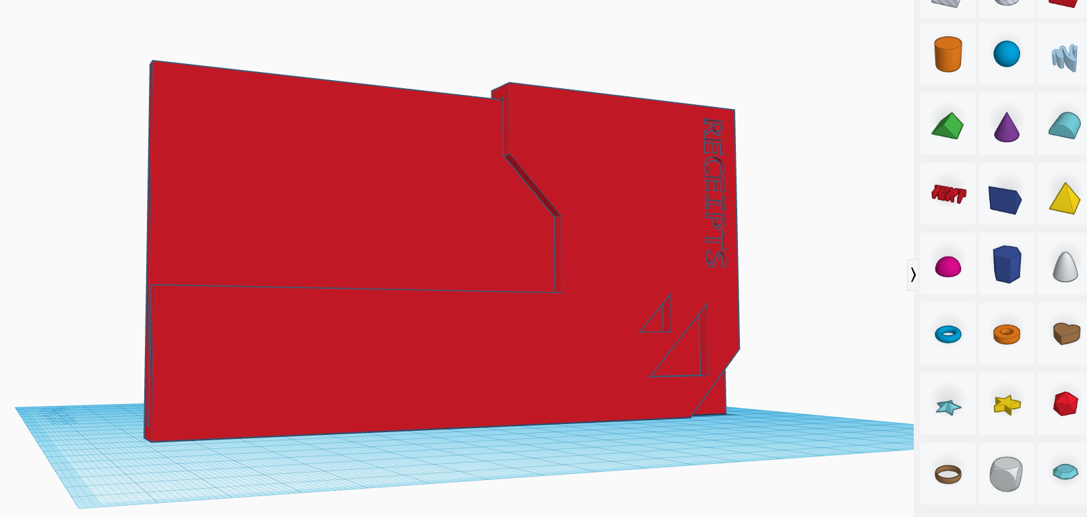

# Creating model

To create a model, start off by logging in and clicking on the “+ New” button in the top right. 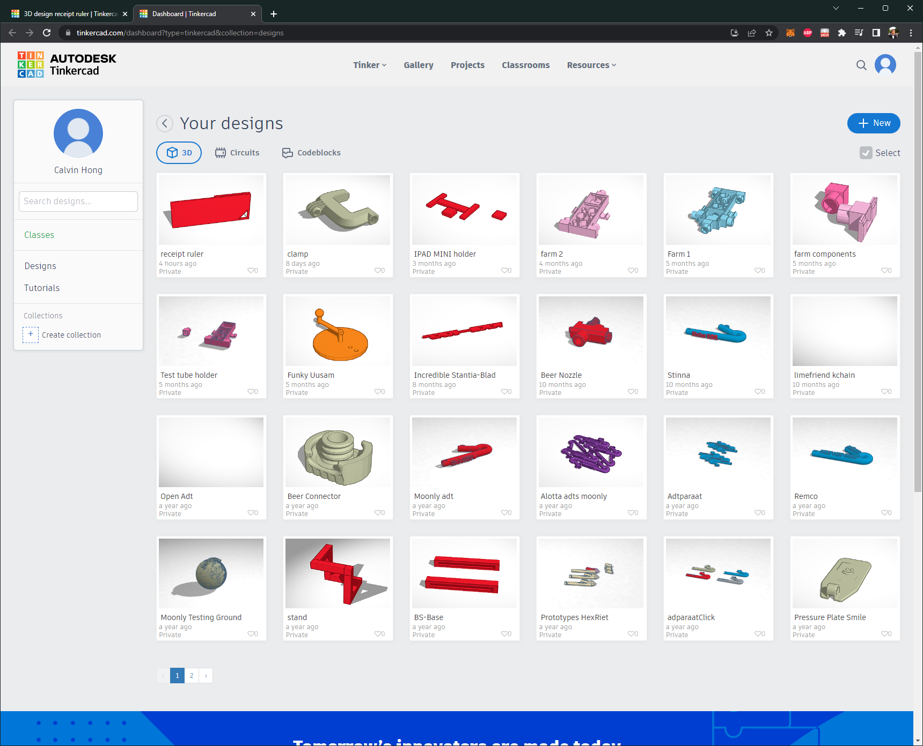

This will takes you to the workplane screen.

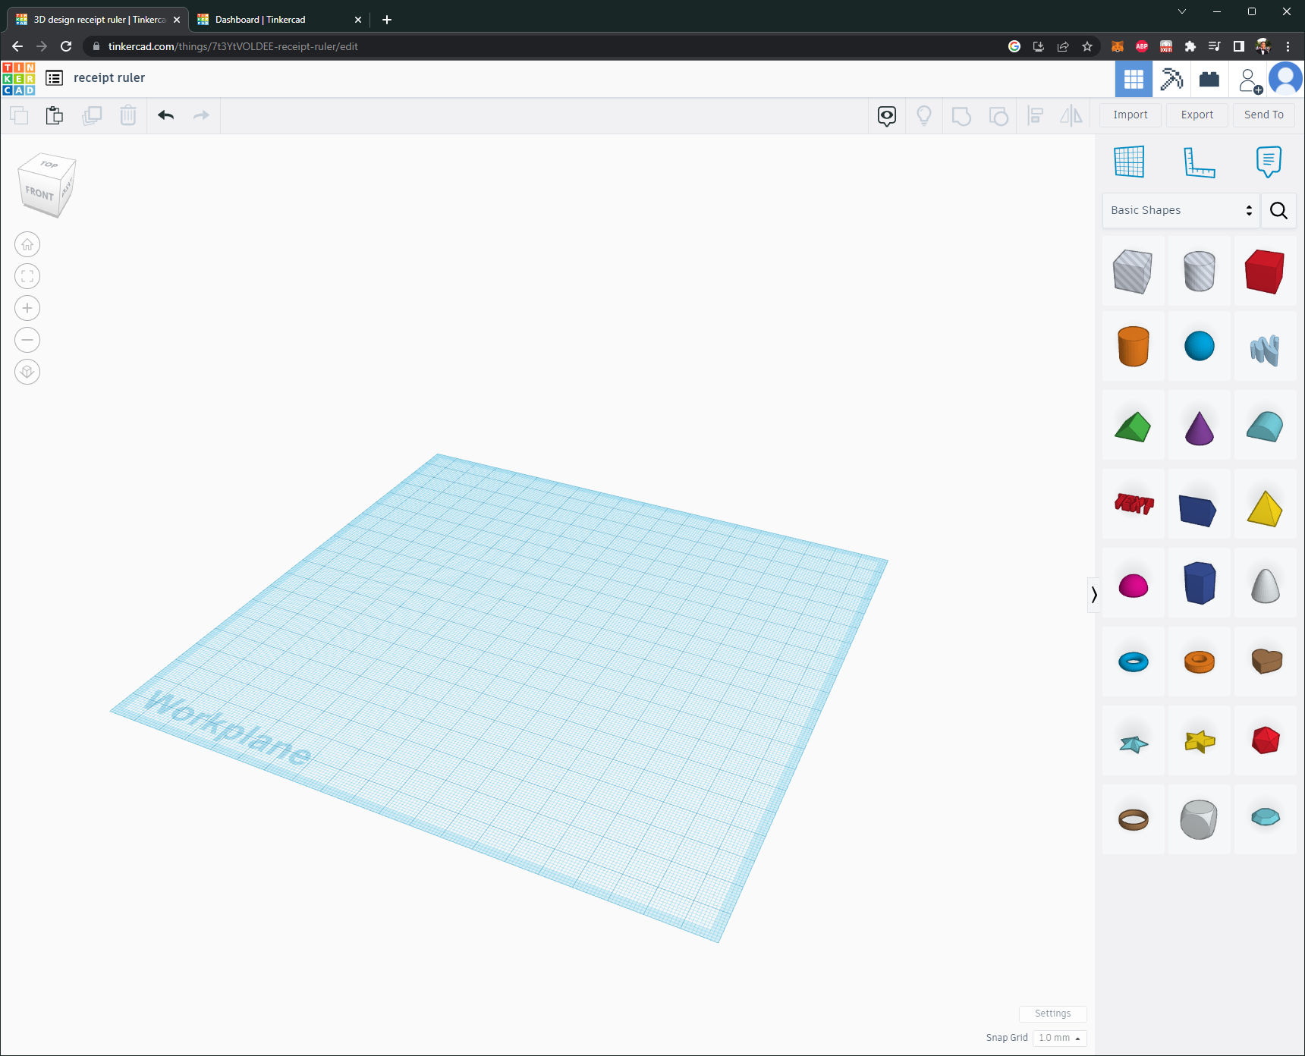

In this screen, you can take models on the right and create what you want. In this case, its going to be a custom receipt ruler. This ruler should block certain information on a receipt. Firstly, the parts that are needer are marked.

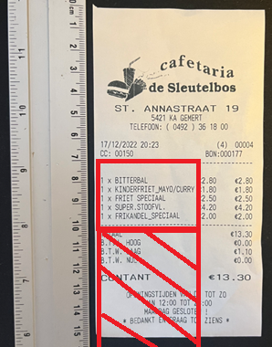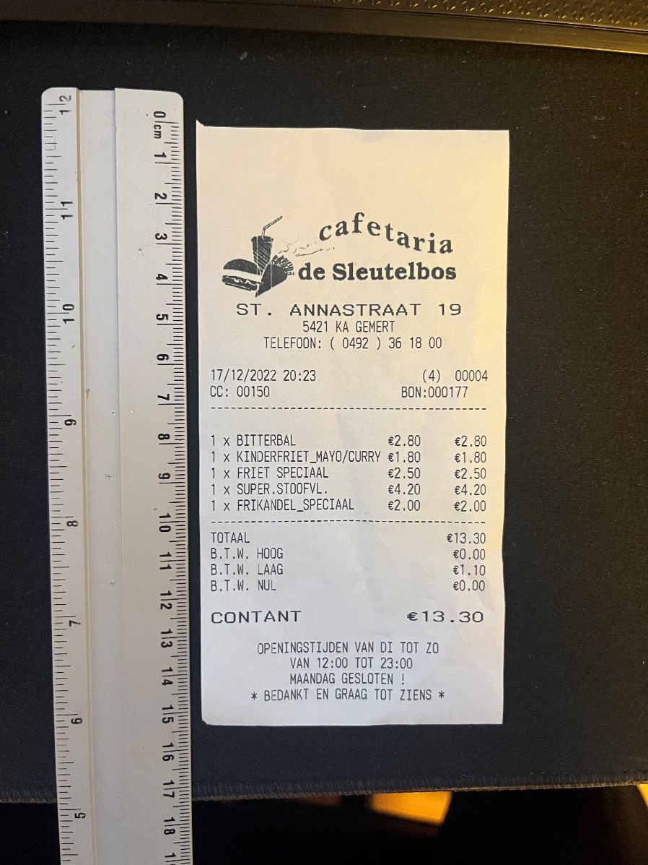

The current idea is to create a cover that blocks the unnecessary information. The measurements are:

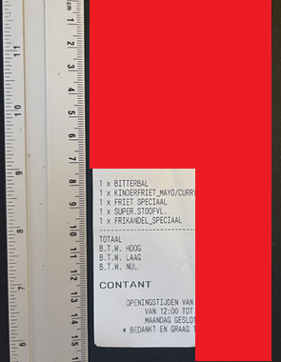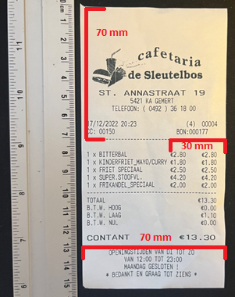

Using these measurements, we can start creating the ruler.

We can start by removing the top logo with the information. The measurements are: H:70MM W:79MM. The thickness can be decided by yourself. In my case, 3MM since I will use it in rougher environments.

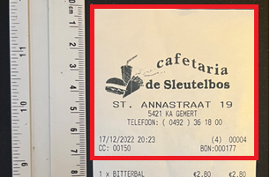

Begin by dragging a cube into the workplane.

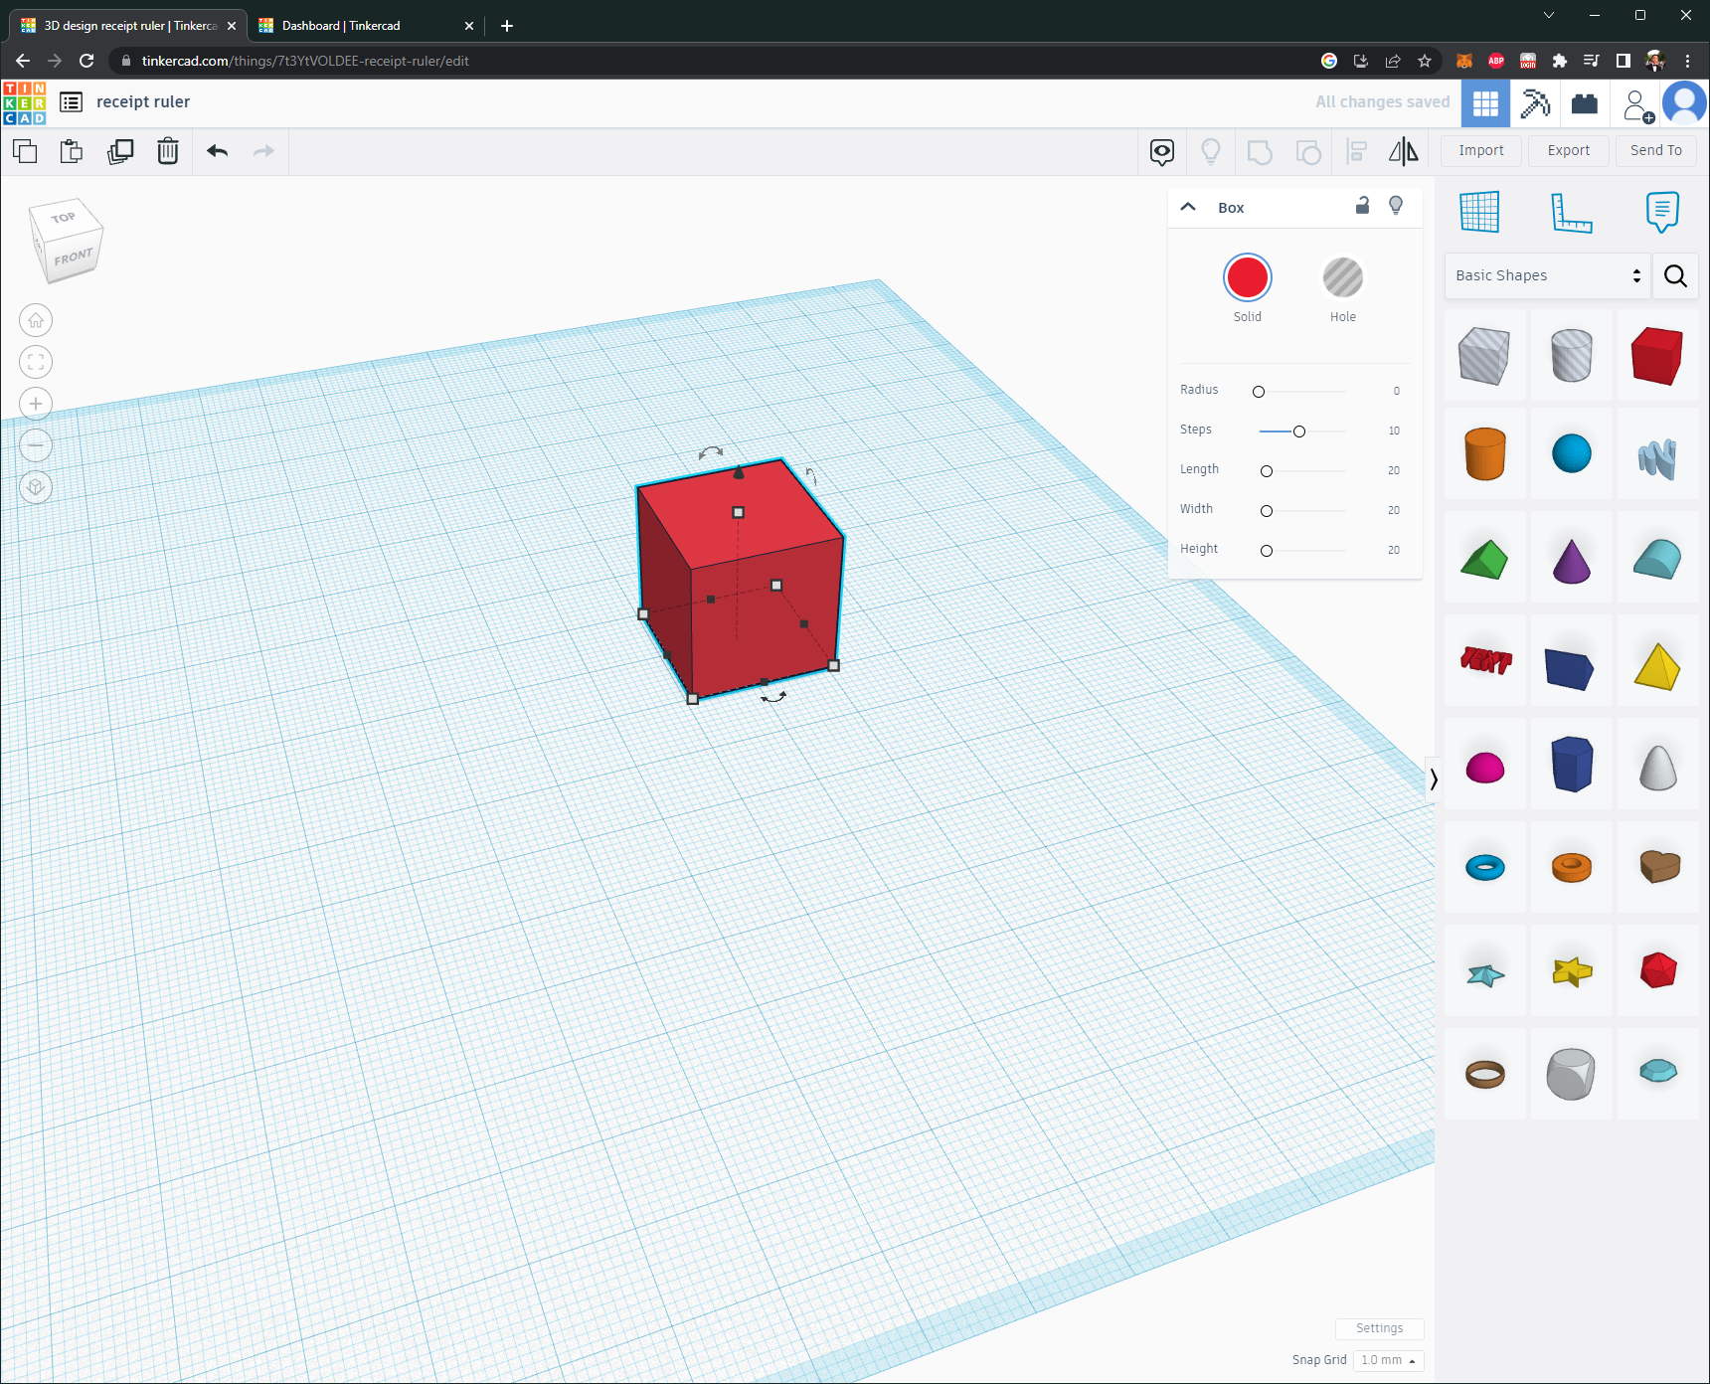

Clicking on the dots on the cube will reveil an input you can change. We can start with the height: 70mm.

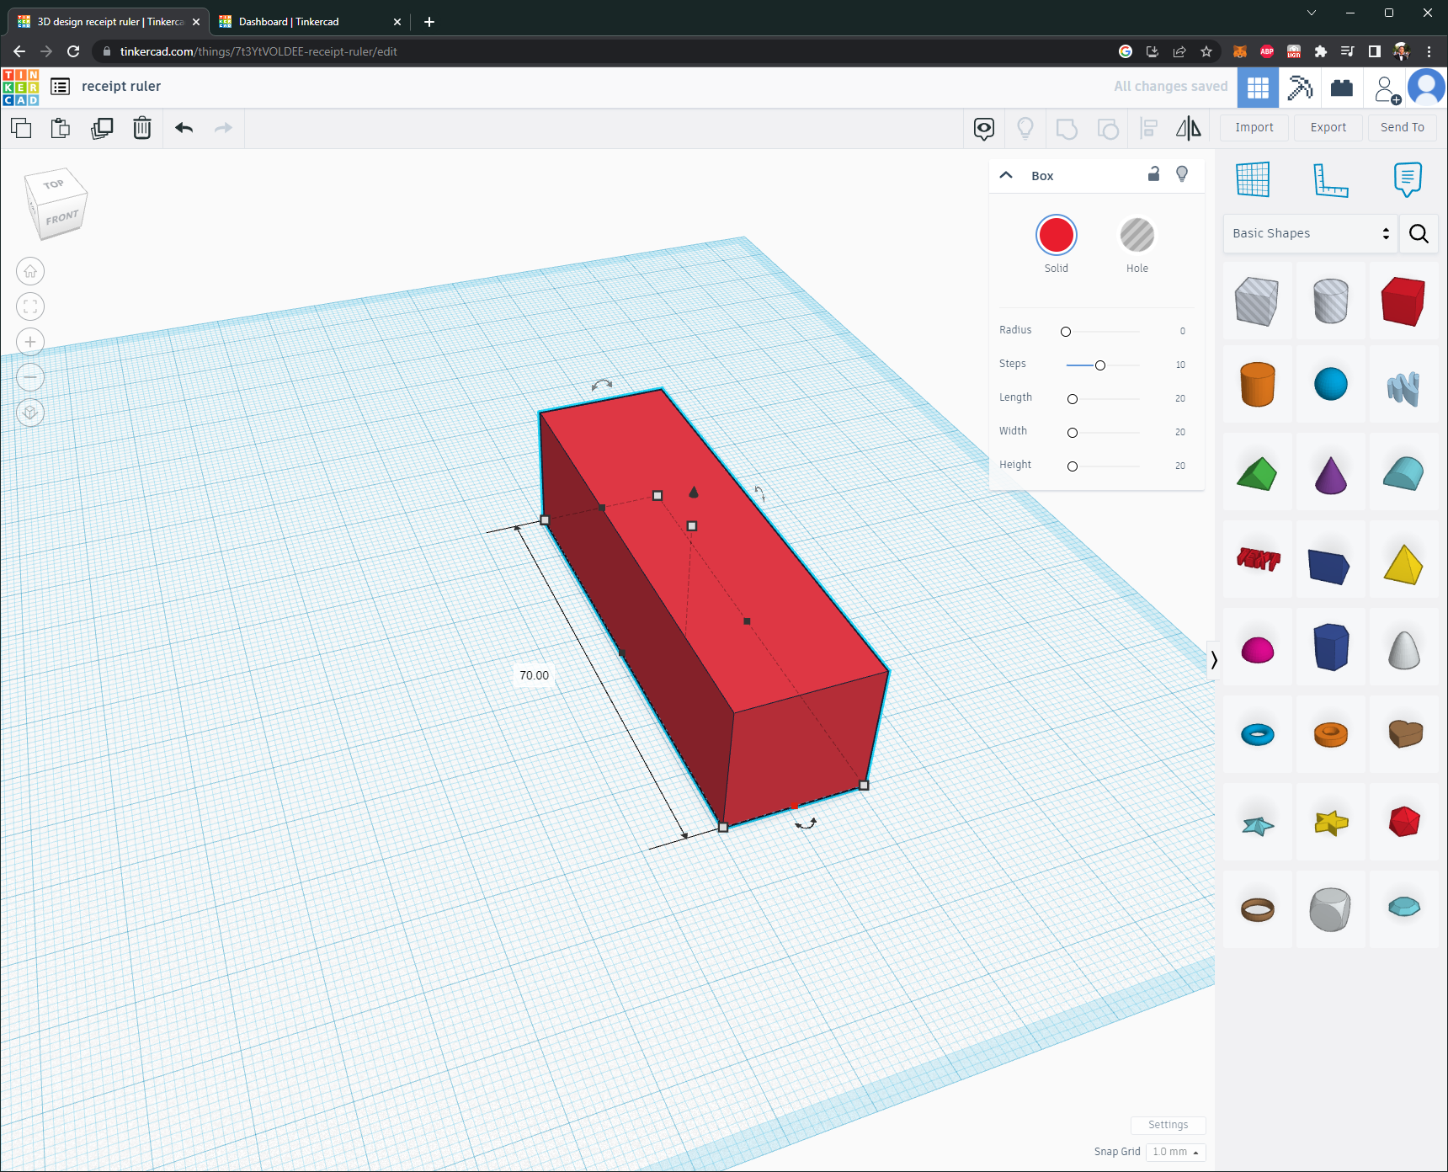

Doing the same for the other measurements will result in something like the following.

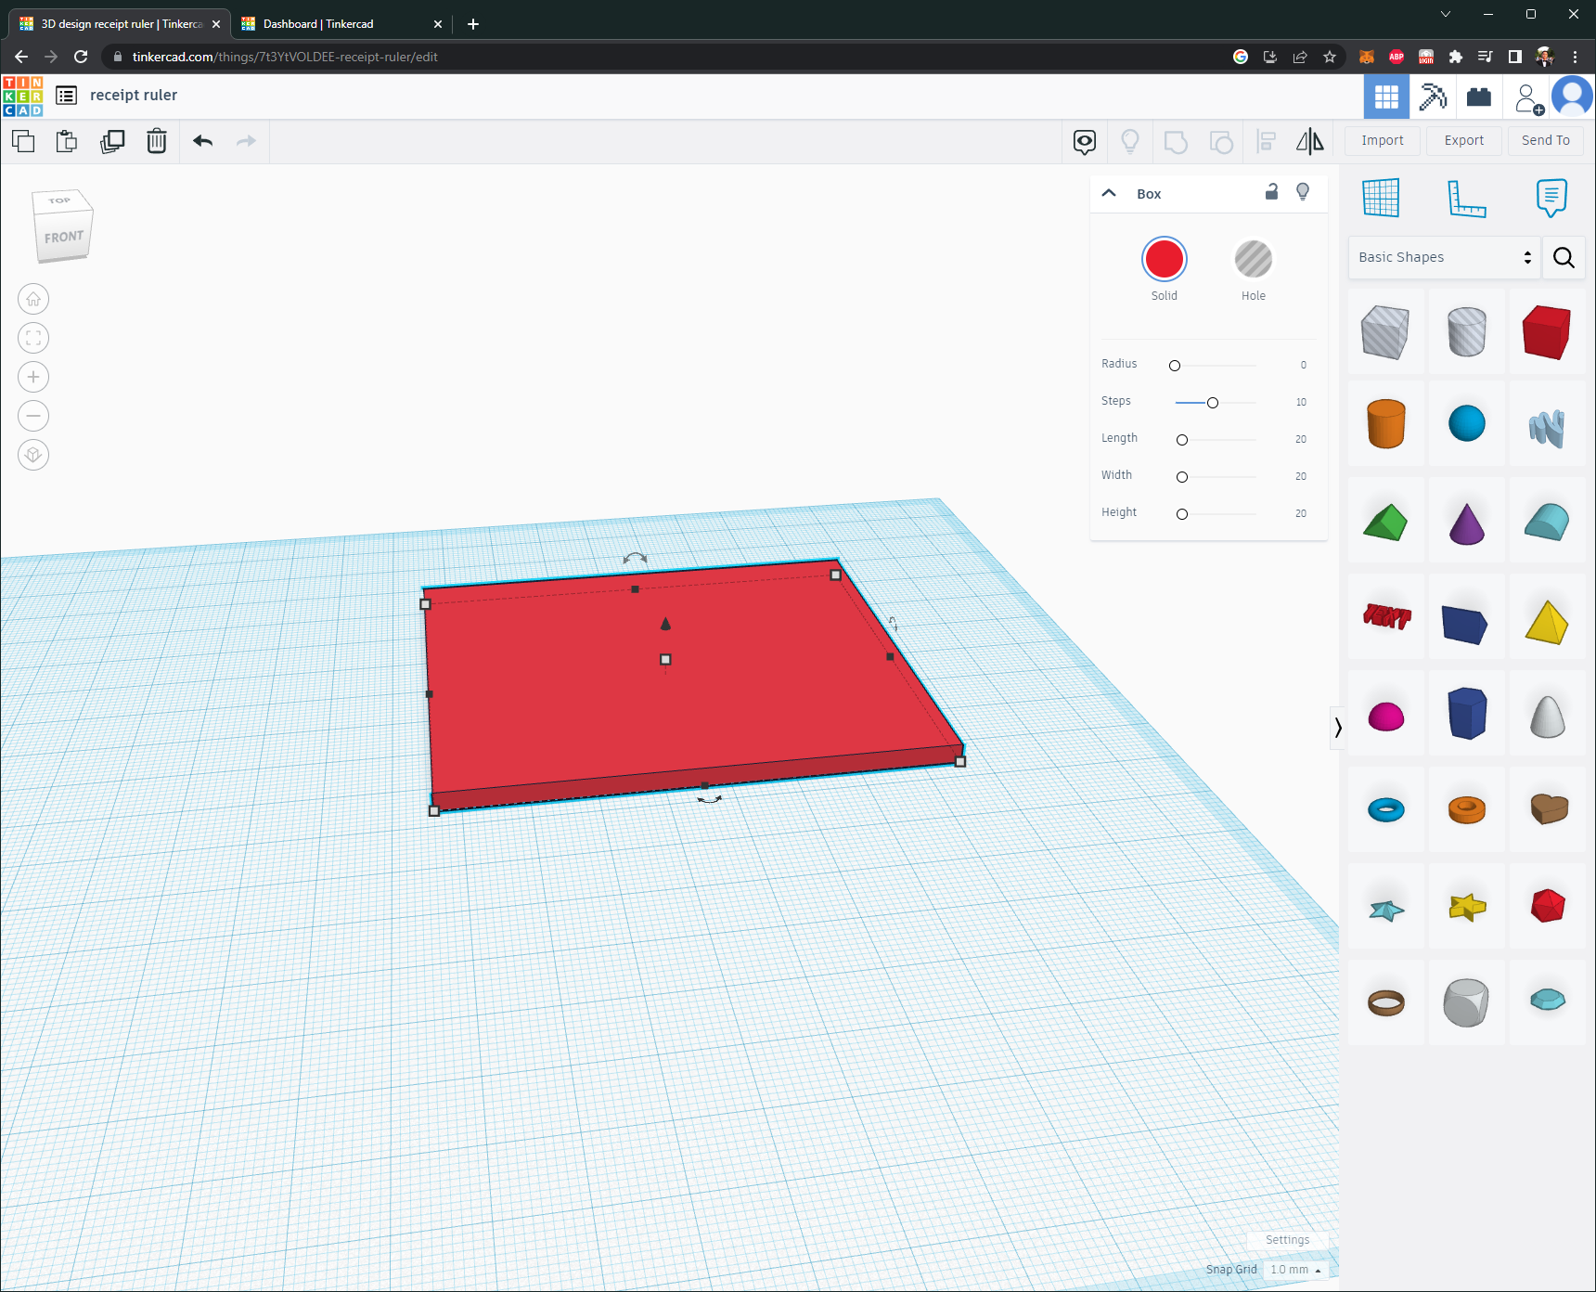

These steps should also be done for the next part.

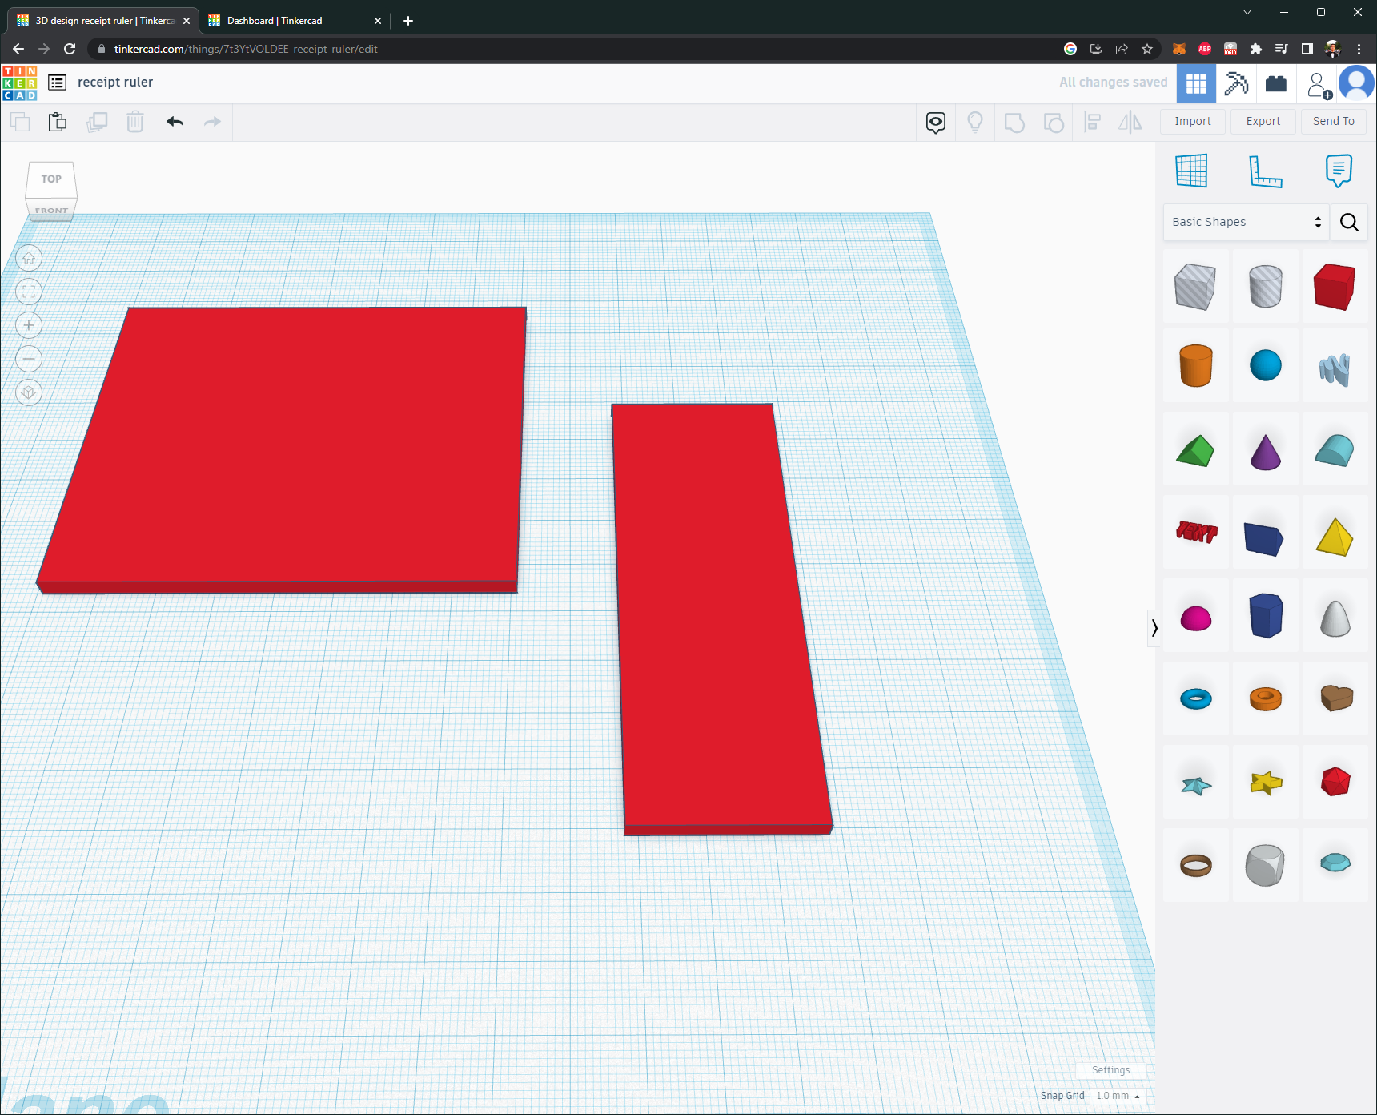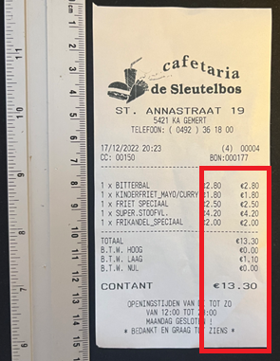

These two pieces can be combined by selecting both of them and clicking the “Group” button (or CTRL+G). Make sure they are in the correct position before grouping.

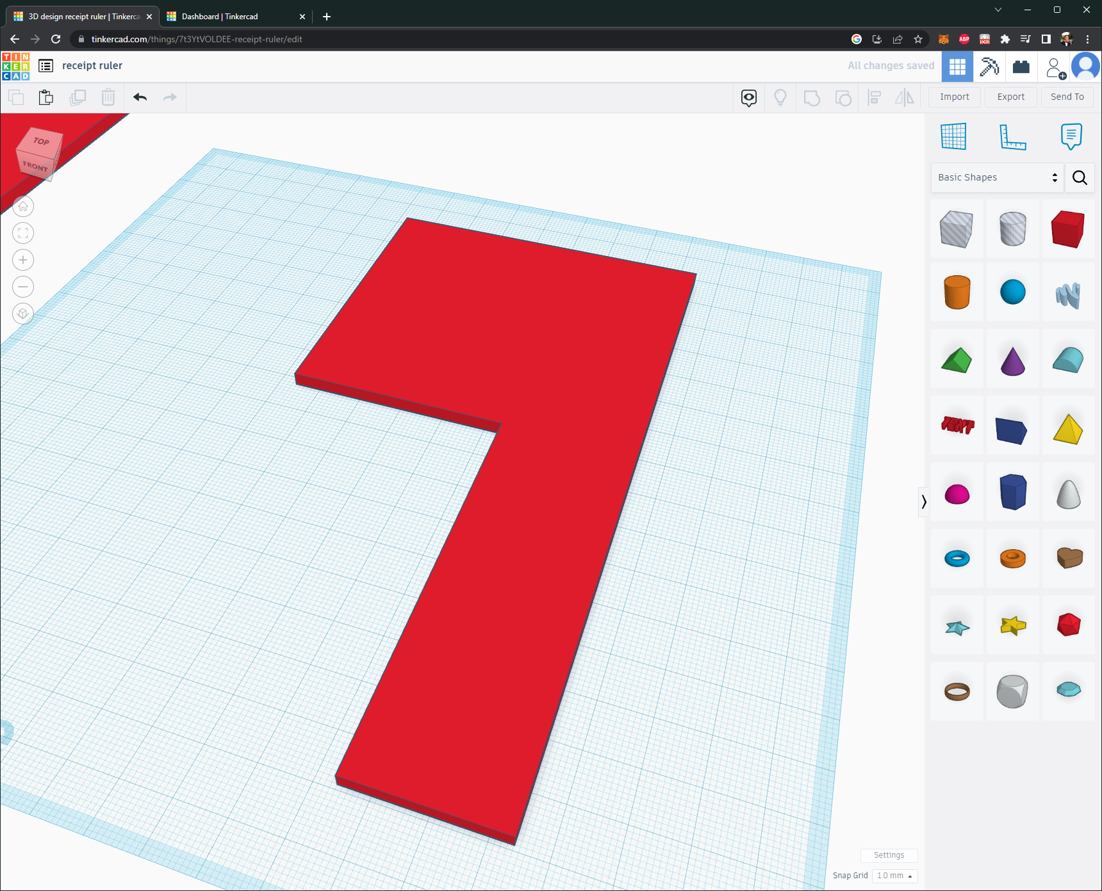

And done! This simple cover can be made in a couple minutes. By repeating these steps, a simple case has been made for only showing relevant information on receipts.

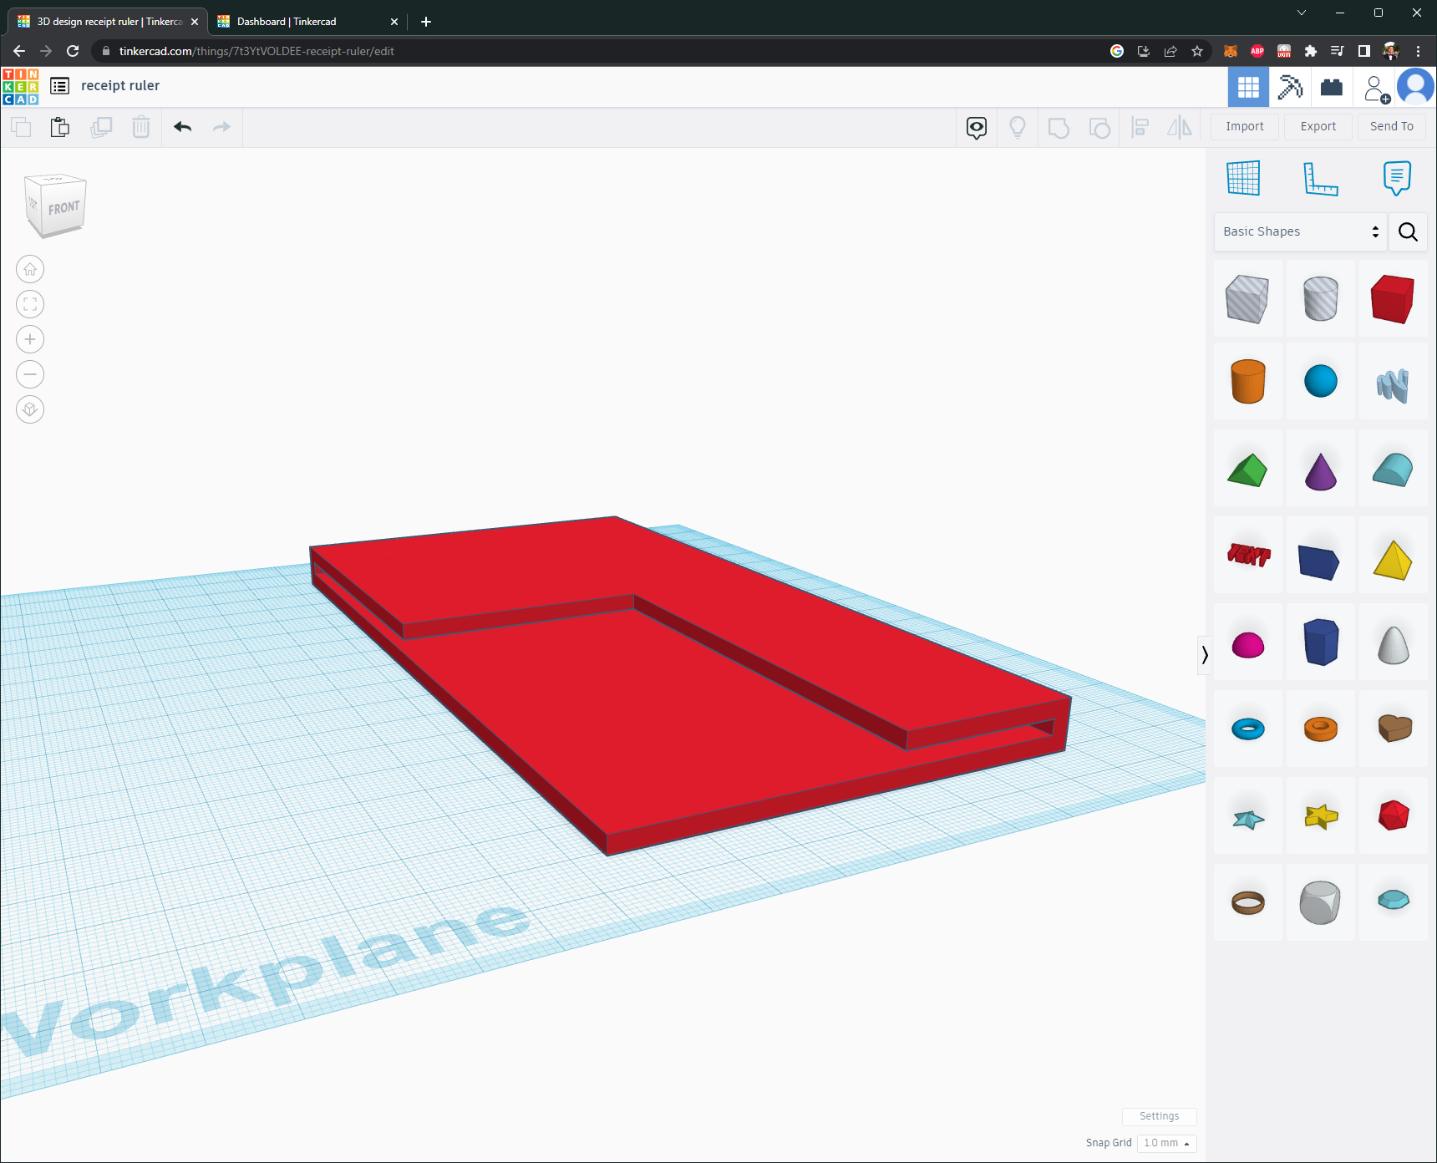

The models can be made more detailed if more time is spent designing. The finished looks like the following.

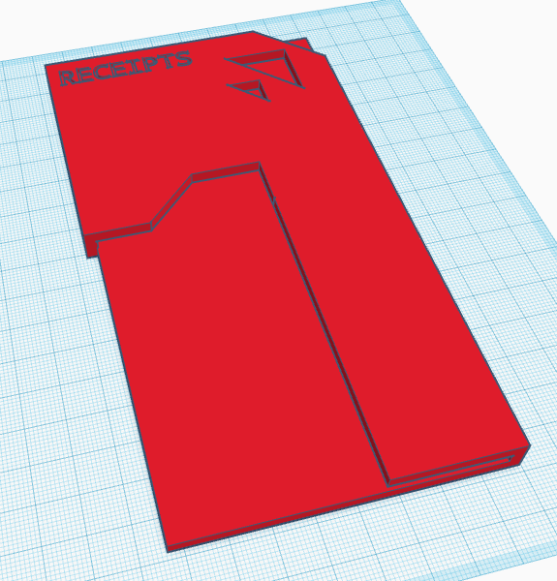

Models can also be found on online websites. One of the most popular sites is: [Thingiverse](https://www.thingiverse.com/).

This model can be exported as .STL or .OBJ. We will need this model file for slicing

# Slicing

Slicing in 3D Printing means preparing a 3d model for printing. Slicing transforms a 3D model into a set of instructions, compiled into a .GCODE (Geometric Code) file. This .GCODE file has all the XYZ movements the printer needs to do for the print. Depending on the Slicing program you use, you could have major differences, like print speed and quality.

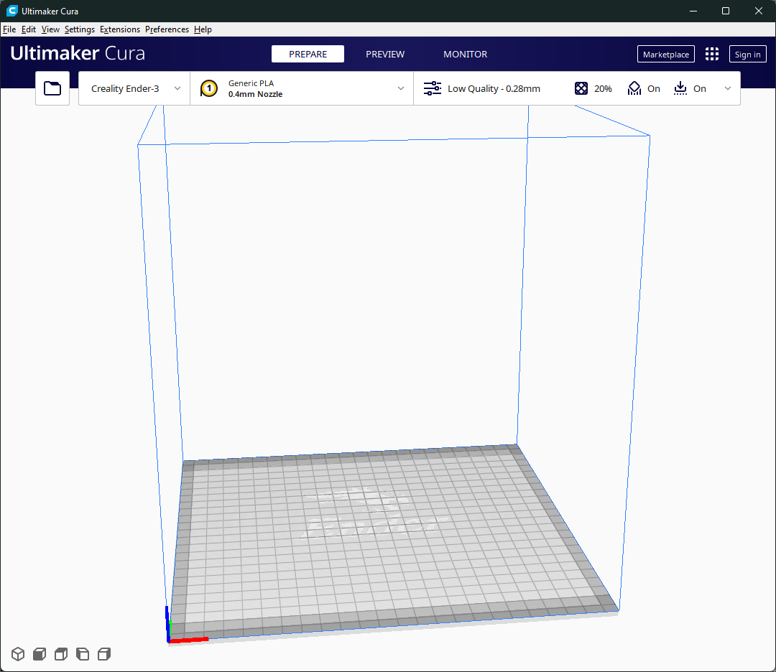For this example, the Slicing program [Cura](https://ultimaker.com/software/ultimaker-cura) is going to be used. Open the program Cura. Just like Tinkercad, this program also has a workplane adjusted to the 3D printer you have. The first step is to import the 3D .STL or .OBJ file you created in the previously.

The settings on the top bar should be adjusted to your current specifics. The combination of settings are nearly endless and are different to every printer. For example, the printer used for this project has certain upgrades that changes these settings (like bed springs, bed surface, and different extruder parts.

A good place to start is to get a template settings from internet and adjust from there on. These are the settings used for this print.

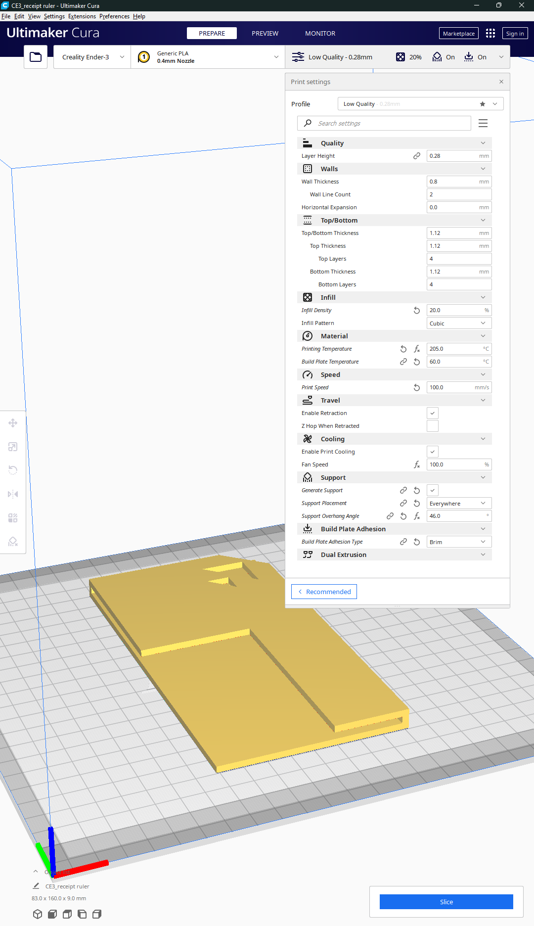 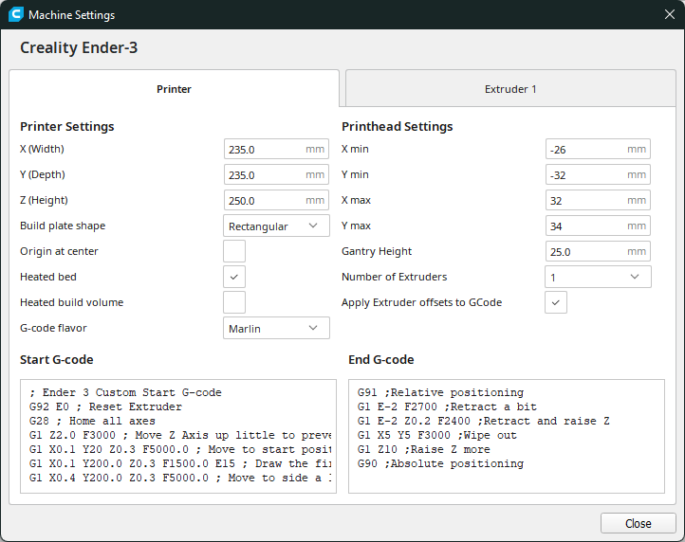

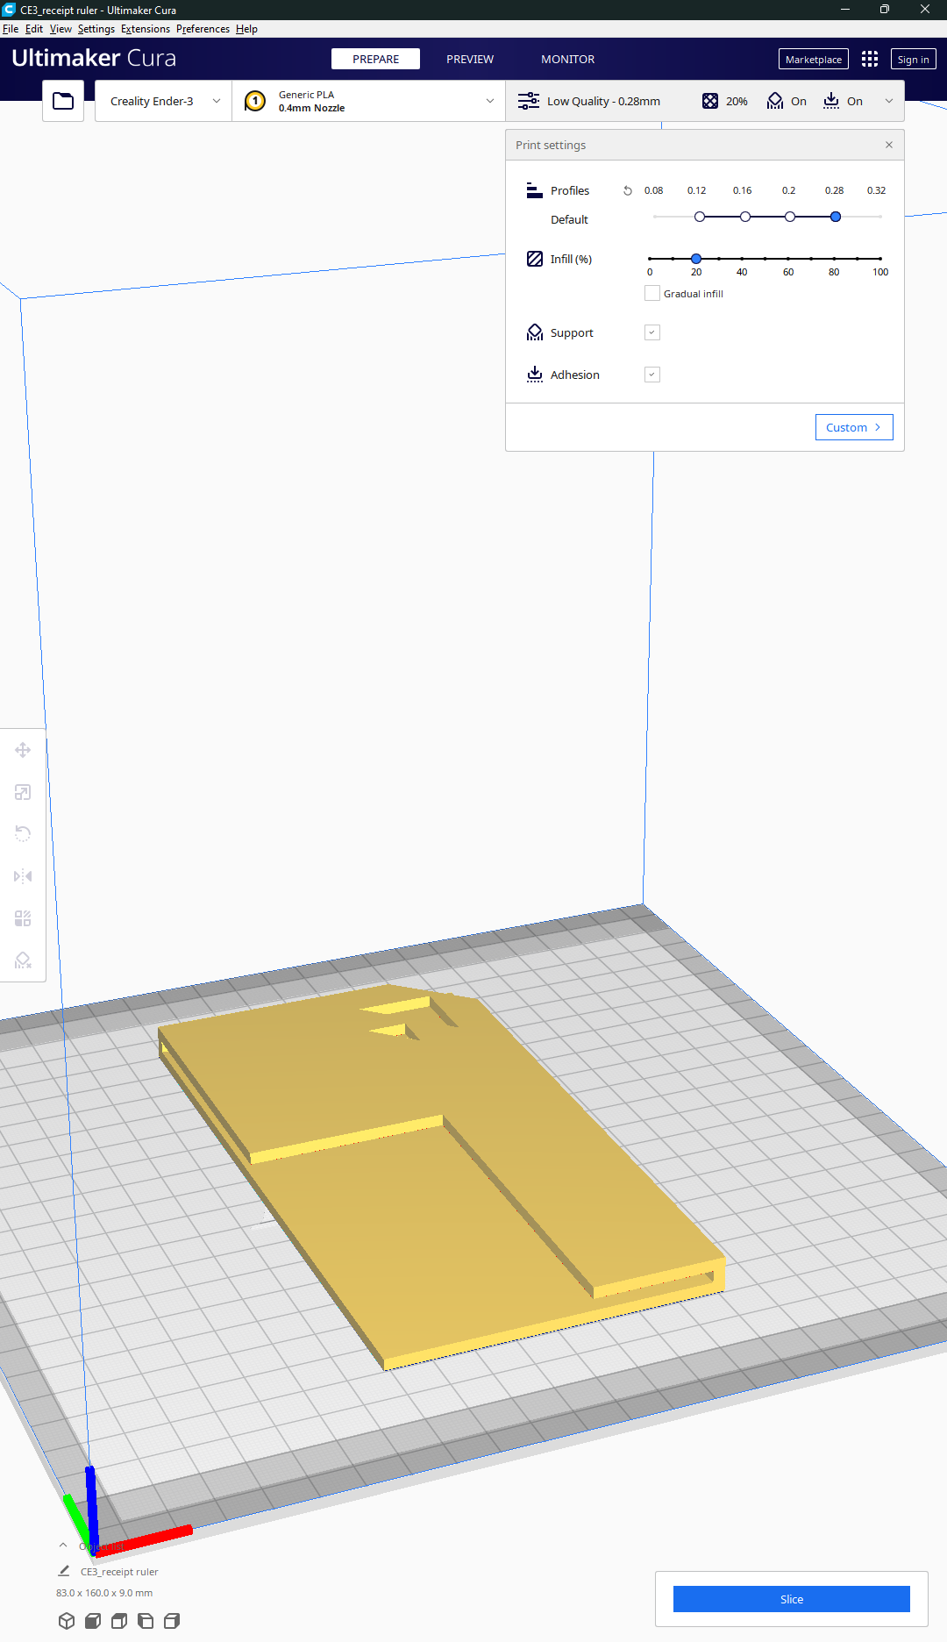

After this, place your model in the right orientation. Try to have as little overhang as possible. Since 3D printers print layer by layer, overhang can ruin a print. This happens because the printer will try to print a layer in midair. This newly printed layer will fall down, leaving a gap. This will continue until it’s finished, possible resulting in this monstrosity. 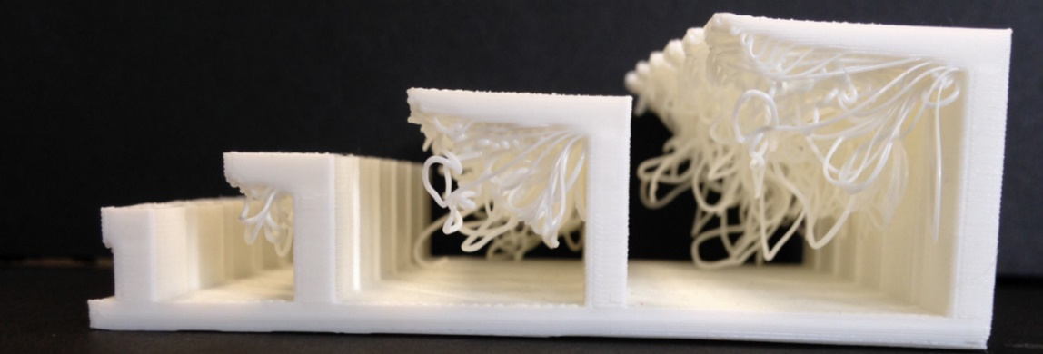

The orientations with the lowest overhang in this model are:

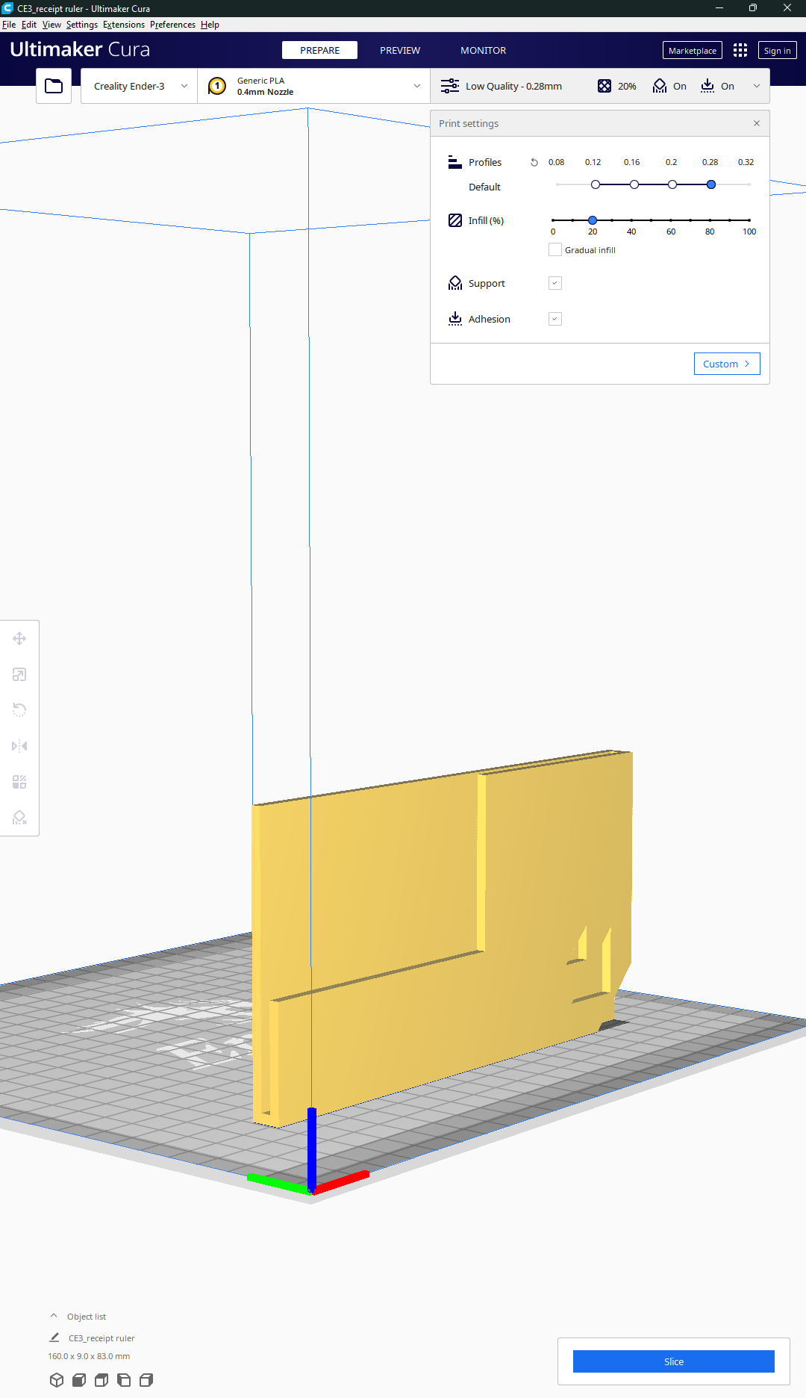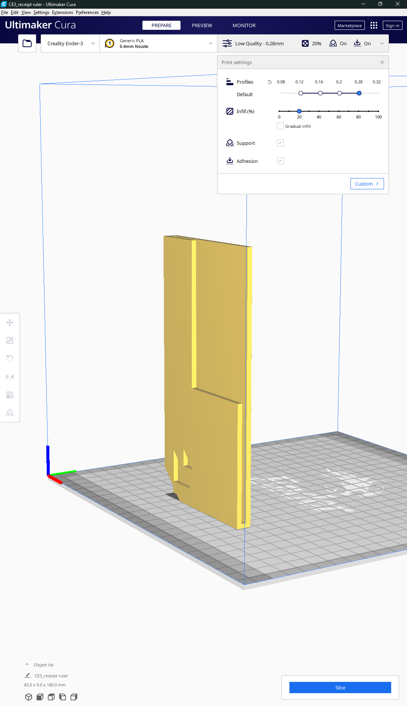

But there is another point to keep in mind, surface area on the building plate. The print should stick and stay stuck on the build model. Since if it pops off, the print will fail and the printer will start making filament clouds instead of your model.

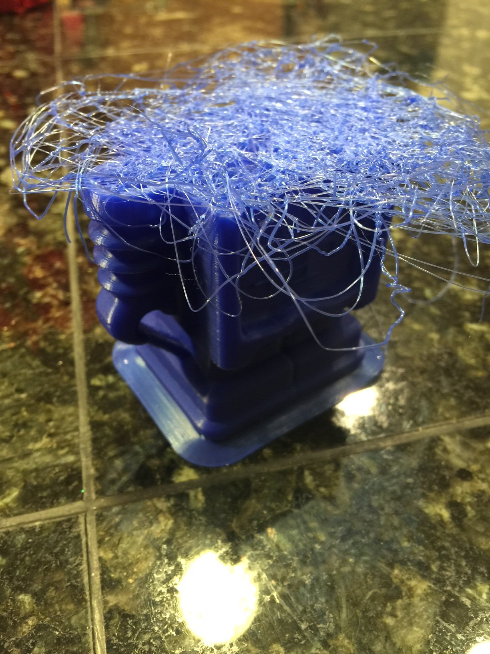

If everything looks okay, the slice button on the bottom right can be pressed. It will then start slicing the model and give an estimated printing time and filament usage. 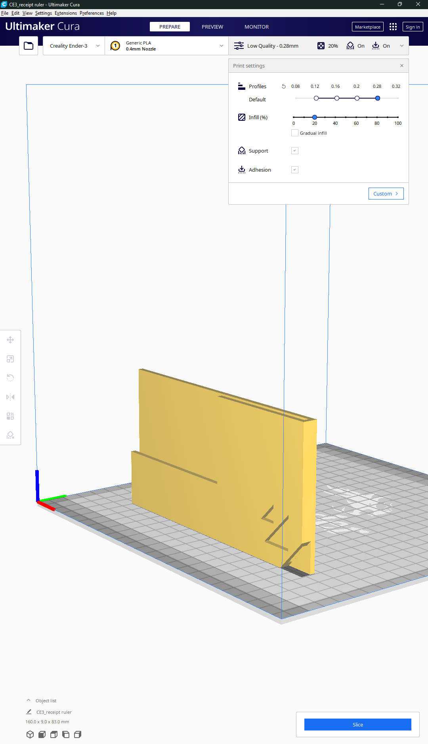

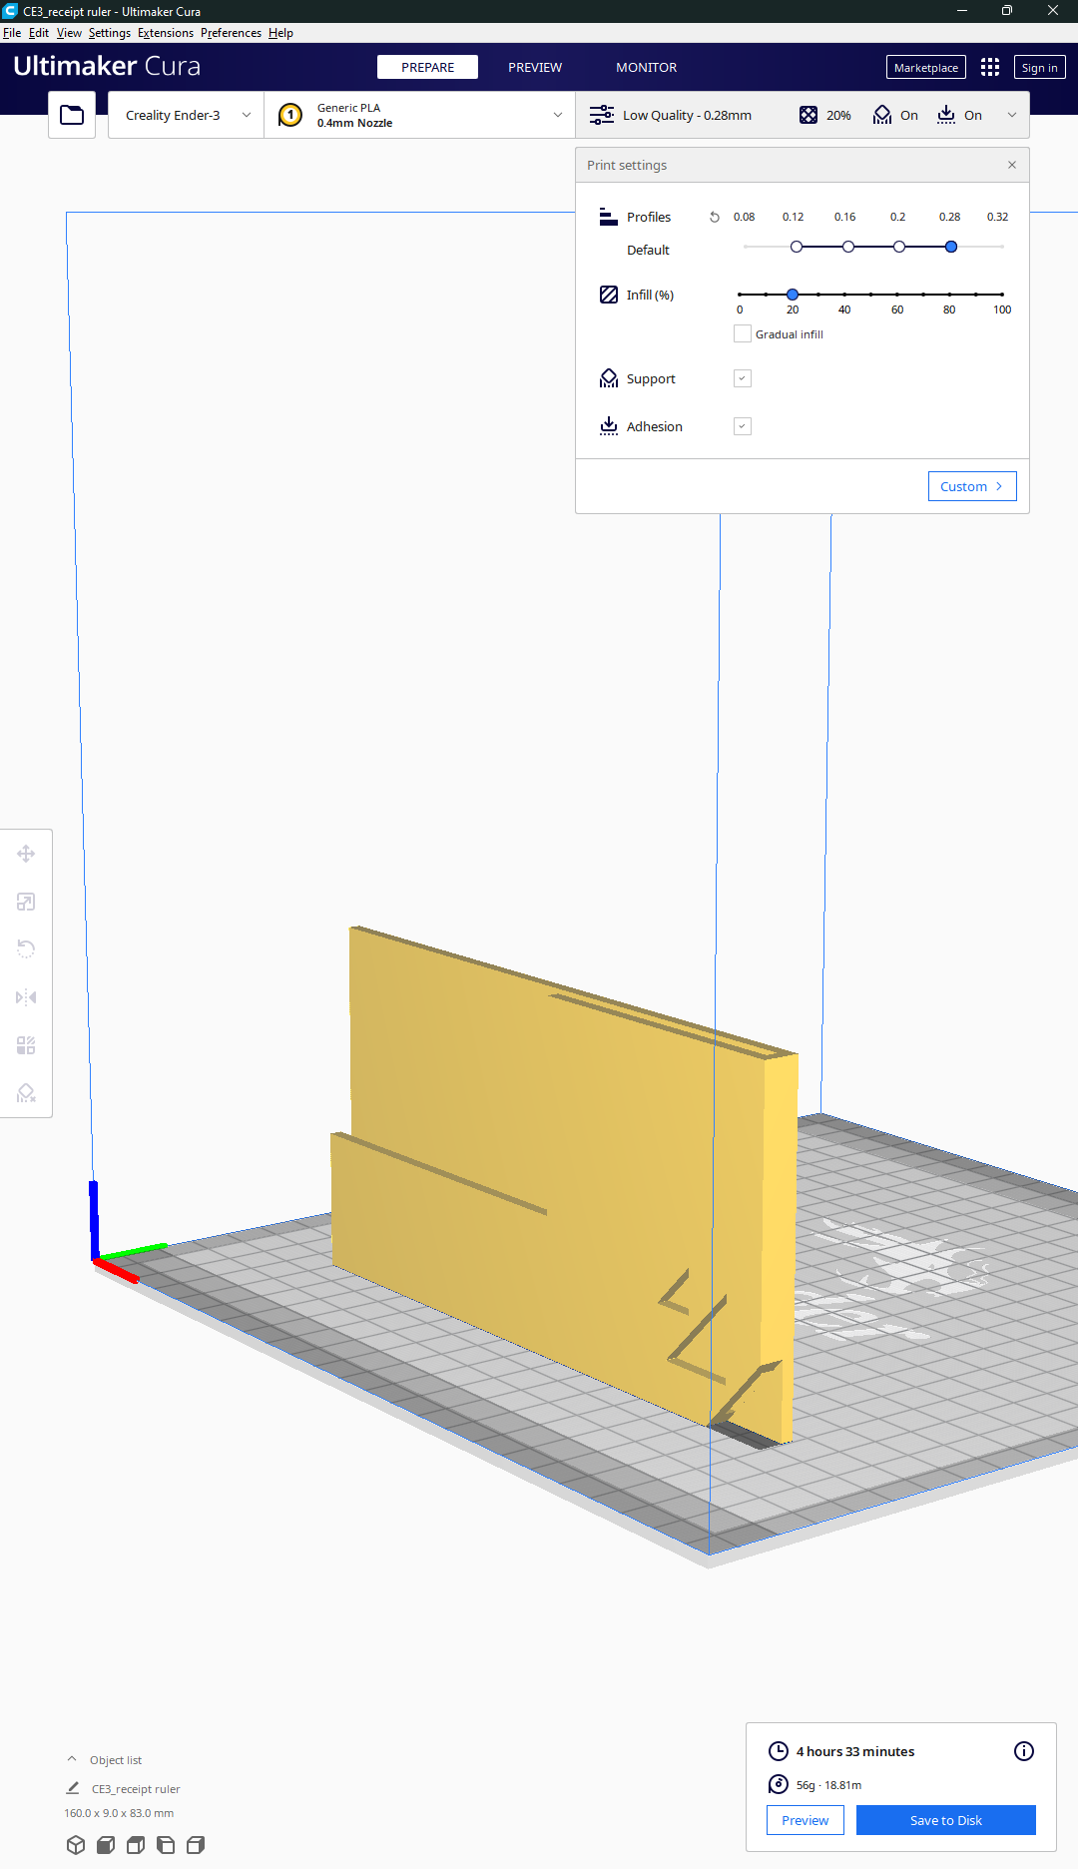

Save the .GCODE onto a micro SD card and stick it in your printer.

If all is successful, the print will start and look something like this:



# Conclusion

3D printing is not too hard if you spent a little time creating models and configurating your printer. Using this technology, a custom receipt ruler was made with the function of only showing relevant information.